# Prototyping:

## Introduction:

At prototyping phase, multiple amplifiers are to be tested and compared with each other. For each of these tests, a small PCB with pre-defined inputs and outputs is to be printed. On the main PCB, there is a pre-defined socket / header for this small amplifier test PCB. This accelerates prototyping phase and saves money.

* 1. Amplifier’s pre-defined block diagram:

GND

+3.3V

Output (3-pins)

Thermocouple

Ctrl (3-pins)

Amp. Circuit

* 1. Amplifier’s pre-defined input / output header position:

+3.3V

OUT3

OUT2

OUT1

GND

CTRL3

CTRL2

CTRL1

TC-

TC+

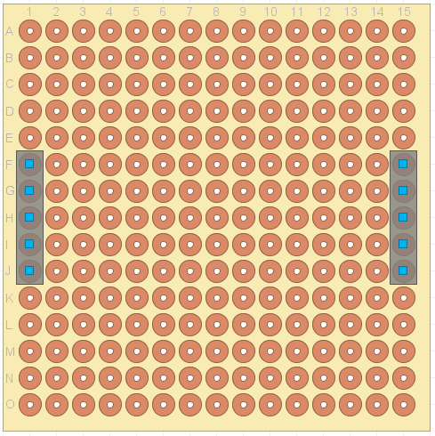

# Tested amplifiers:

## Single BJT transistor amplifier:

Using BC337 BJT NPN transistor, the following circuit is implemented. It gives a gain of 5 [V/V], enabling an ADC resolution of

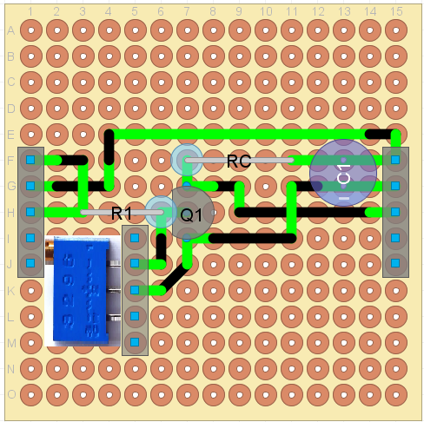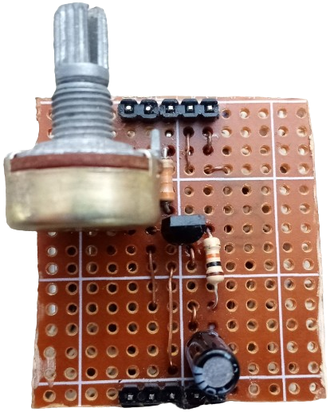

### Design notes:

* As BJT amplifies $I_{B}$ at $I_{C}$, and since $I_{C}=\frac{3.3-v_{o}}{R_{C}}$, value of $R_{C}$ must be low enough such that the amplified current is achievable across it. This could also be achieved by checking that $v_{CE, Fully On}≅0.2V$. Otherwise, if $v_{CE, Fully On}≅few mV$, the operation will not be as expected.

### Disadvantages:

* Has a low gain. To obtain higher gain transistors should be cascaded, which takes more cost when compared to the following circuit.
* Automatic offset calibration is not stable.

## Op-Amp based amplifier:

* Using UA741CN Op-Amp, the following circuit is implemented. It gives a gain of 33 [V/V], enabling an ADC resolution of $\frac{1}{4096}*\frac{3.3}{33}≈24.4μV/LSB$. It also provides stable automatic offset calibration.

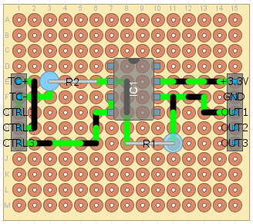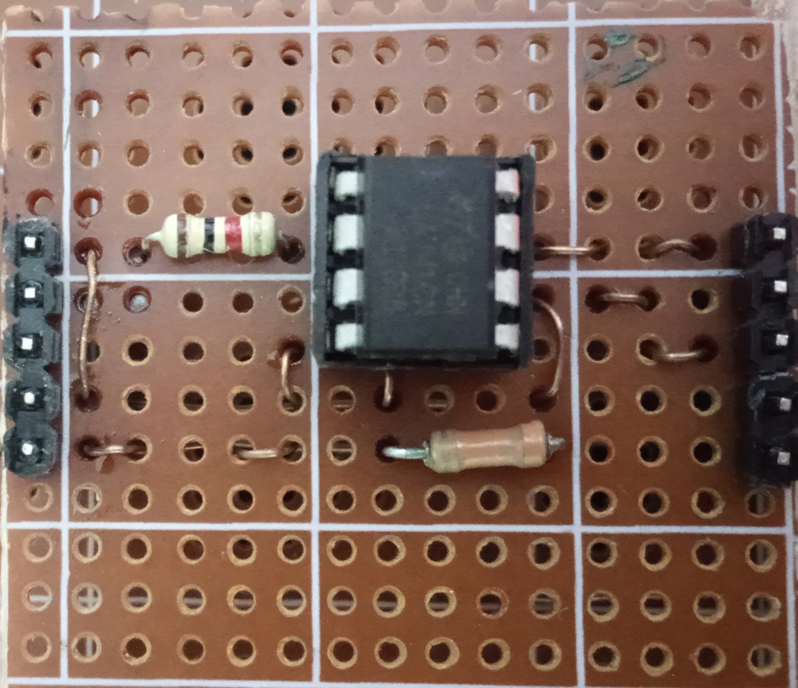

### Design notes:

* As this is – obviously – an inverting amplifier, thermocouple is connected in reverse to obtain positive output.
* **CTRL2** signal is used to select whether thermocouple is connected to the circuit or not. This is achieved by switching **CTRL2** between 0-volts level, and open-circuit level respectively.
* **CTRL1** signal is used to select whether circuits input voltage is a fixed 0-volts, or thermocouple voltage. This is achieved by switching **CTRL1** between 0-volts level, and open-circuit level respectively.
* **CTRL3** is fixed at 0-volts level all time, and used as a **GND** for the op-amp circuit. This is done so that when **CTRL1** or **CTRL2** signals are low, they appear as real zeros to the op-amp. As low level voltage of the I/O module in the MCU is always a little value above zero (real circuit **GND**).
* To calibrate offset, thermocouple is disconnected (**CTRL2** is open-circuit), and amplifier’s input is set to zero (**CTRL1** is zero). Hence, output value is equal to that of the offset).
* To obtain thermocouple’s voltage, thermocouple is – of course - connected (**CTRL2** is low), and amplifier’s input is dedicated to TC only (**CTRL1** is open-circuit). Hence, output value is equal to:

$$A_{V}* v_{TC}+v_{offset}$$

By subtracting offset value (previously obtained at a periodic calibration) from output’s value, thermocouple’s voltage can be obtained as follows:

$$v_{TC}= \frac{v_{out}- v_{offset}}{A_{V}}$$

# Temperate calculation:

As thermocouple temperature calculation depends on its voltage, and temperature of the – virtual – cold junction. Temperature of cold junction is assumed to be room temperature, which could be measured using STM32’s on-chip temperature sensor.

Temperature can be calculated as follows:

$${v(T)}_{|T_{ref}}={v(T)}_{|0}-{v(T_{ref})}_{|0}$$

### In the above equation:

* The term ${v(T)}_{|T_{ref}}$ is thermocouple’s voltage $v_{TC}$ (Previous section discussed how to obtain it).
* The term ${v(T_{ref})}_{|0}$ could be obtained by interpolating output of the on-chip temperature sensor, in thermocouple’s reference table.
* Hence, the term ${v(T)}_{|0}$ can be obtained from the equation as follows:
$${v(T)}_{|0}={v(T)}_{|T_{ref}}+{v(T_{ref})}_{|0}$$

* Voltage ${v(T)}_{|0}$ is then interpolated in thermocouple’s reference table to obtain value of $T$.

# Noise elimination:

## Temperature noise:

From the previous calculation, the obtained temperature is coupled with noise (Due to amplifier circuitry). These are eliminated using a SW defined LPF.

## On / Off control hysteresis:

To avoid multiple fast relay switching which may affect both relay circuit and the load device, a hysteresis filter is defined.

Also, relay protection SW is implemented. All it does is inserting minimum delay between switches requested by the controlling SW.

# I/O:

* Set-point temperature is controlled using the on-board rotary encoder.
* Set-point temperature and real temperature are shown on a multiplexed 3-digit 7-segment display.

# Porting and configuration:

* This SW is built to be portable for variety of MCU’s, just replace FreeRTOS and COTS-OS/MCAL port files with these of the used target MCU.
* SW is modular and can be easily modified when using different HW setup, or when implementing additional features.

# Prototype: